**Experiment - 2**

**Aim:**

**WAP using variables in PROLOG.**

**Solution:**

* **Prolog code:**

domains

city,state,person=symbol

predicates

Location(city, state)

Stays(person,city)

Res(person,state)

clauses

Stays("Aanandi","Rajkot").

Stays("Devanshi","Jamnagar").

Stays("Riya","Gandhinagar").

Stays("Aash","Udaipur").

Stays("Bhargav","Amritsar").

Location("Rajkot","Gujarat").

Location("Jamnagar","Gujarat").

Location("Gandhinagar","Gujarat").

Location("Udaipur","Rajasthan").

Location("Amritsar","Punjab").

Res(P1,S1):-

Stays(P1,X),Location(X,S1).

* **Output screenshot**

1. **List of all people, state and city:**

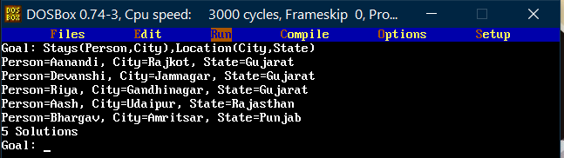

1. **Person <-> state:**

**Method-1:**

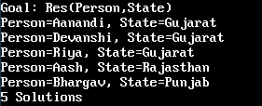

**Method-2:**

